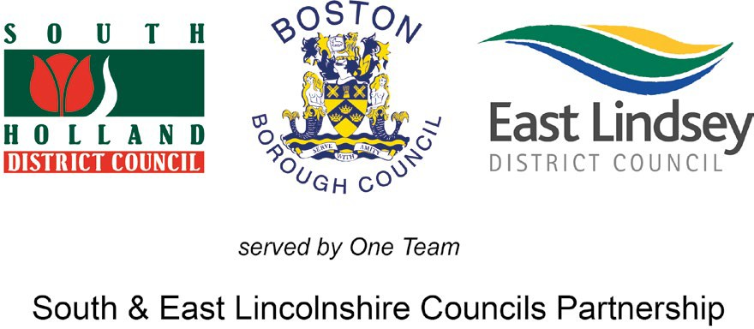 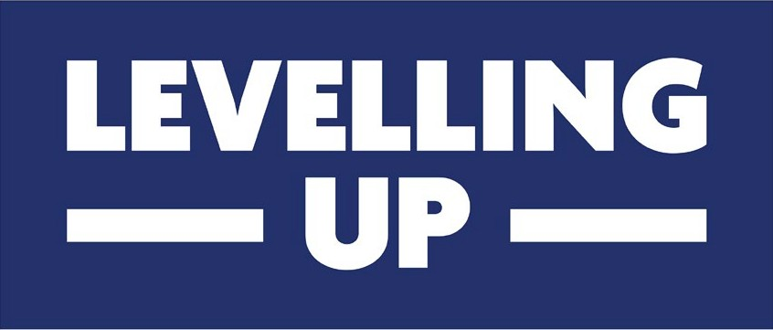



Expression of Interest Form

Please read the **‘How to apply for Funding’** section before completing and submitting this form.

# Contact Details

1. Full project name:
2. Name of bidding organisation:
3. Full Postal Address:
4. Postcode:
5. Website:
6. Contact name:

**8.** Email:

**7.** Position:

**9.** Telephone:

# Organisational Details

**10.** Date established: **11.** Current turnover:

1. No. of employees:

**FT: PT:**

1. Legal status (Please tick **one** box):

Sole trader Limited company Charity Voluntary

Social ent

Partnership org

Sectorial or networking group Public sector

Quango

Other (Please specify):

1. Company / Charity number:



1. VAT number:



1. VAT registered: Yes No
2. Brief description of organisation (History / purpose / role):

# About your project

1. Please tell us which theme is the best fit for your project: Community & place

Supporting local businesses People & skills

1. Please provide a brief summary of your proposed project:
   1. What you hope to achieve?
   2. Are you wishing to be considered as a “Delegated Authority”? (see Prospectus for details) Yes No
   3. How the project will be delivered?
   4. Who will deliver the activity?
   5. Who will benefit?
   6. Where the project will be based/delivered (Within a specific District or across multiple Districts)
2. Please provide details of your organisation’s capacity and experience in developing and delivering this type of project.
3. Tell us about the type of activity you are looking to address. Select the strands or local priorities that best fit your project from sections 1.7.1, 1.7.2 & 1.7.3.

*Example: E1 – Improvements to town centres & high streets*

1. Specifically what types of outputs will you look to deliver? (Selecting from tables 2.1 – 2.3)

*Example: Jobs Created, Increased Visitor numbers or New Businesses Created*

It is important that we know when your project will begin to incur expenditure and how long before outputs and outcomes start to be delivered.

1. Is your project already running?

Yes No

*(If Expenditure, Activity or Outcomes occur in multiple years please tick all relevant boxes)*

1. When will expenditure be incurred?

Within 3 months

In 2023/24

In 2024/25

1. When will activity start?

Within 3 months

In 2023/24

In 2024/25

1. When will outcomes be delivered?

Within 3 months

In 2023/24

In 2024/25

1. What is the estimated total cost of your project? List the main elements of the budget.

**2022/23 (£) 2023/24 (£) 2024/25 (£) Total (£)**

Design & Development Costs (R): Administration/Running Costs (R): Marketing/Engagement Costs (R): Revenue Delivery Costs (R): Capital Delivery Costs (C):

*Other Costs (R+C):

**Est Total Cost:**

*If other costs are incurred please provide details below:

1. Of the total, what percentage are you looking for UKSPF or Rural Funding to contribute?

**(%)**

1. Have you investigated or actively sought alternative sources of matched funding?

Yes No

1. Please provide details of any potential or secured source(s) of matched funding.
2. Is there a likely short fall in your funding model?

Yes No

If yes, how much?

**(£)**

1. Please indicate the key milestones which your project has already achieved: Project design completed

Management & delivery processes agreed All aspects of project costed

Full Business Plan/Case available for review

Project supported/approved internally by Applicant organisation Recruitment complete/resources in place to commence delivery Financial management, governance and reporting systems in place Relevant permissions/licenses obtained

Marketing/Beneficiary engagement plans in place

Delivery risk register available Confirmed Matched Funding in place Project already underway

Other (Please specify):

1. Please list other milestones or KPIs you expect to set for your Project if it is approved:
2. Please list the main challenges or risks associated with the successful delivery of your project and how you propose to mitigate them.

**Challenges:**

**Risks & Mitigation:**

**Equalities and diversity**

1. List any positive or negative impact that your Project may have on any of the protected characteristics: age, disability, gender reassignment, marriage and civil partnership, pregnancy and maternity, race, religion or belief, sex, sexual orientation.

<https://www.equalityhumanrights.com/en/equality-act/protected-characteristics>

**Net carbon**

1. List any positive or negative environmental impacts that your Project may have.

# Authorisation

By completing this EOI you are confirming that you certify, to the best of your knowledge, that the information submitted on this form is true and correct and that you have the appropriate level of responsibility to submit this EOI on behalf of your organisation.

Signed: Name:

Position: Applicant organisation:

Date:

Having completed this form, please save it to your device before emailing it to [UKSPF@sholland.gov.uk](mailto:UKSPF@sholland.gov.uk)

SHDC, ELDC and BBC are “Joint controllers” for the processing of your contact details during this expression of interest (“EOI”) stage. The submission will be shared with those partners who form the Theme and Local Partnership groups, some elements of the expressions of interest may be disclosed where we are legally obliged e.g. Police or under the Freedom of Information Act.

The Council will retain your EOI application for a minimum of 2 years for accountability and audit purposes. Each Council has a privacy policy outlining your rights:

**South Holland:** [www.sholland.gov.uk/privacy](http://www.sholland.gov.uk/privacy) **East Lindsey:** [www.e-lindsey.gov.uk/privacy](http://www.e-lindsey.gov.uk/privacy) **Boston Borough:** [www.boston.gov.uk/privacy](http://www.boston.gov.uk/privacy)